1M1B AI for Sustainability Virtual Internship

Project Creation & Guideline Document
(In Collaboration with IBM SkillsBuild & AICTE)

1. Project Context: How to Think About Your AI + Sustainability Project
Before you begin building your project, it is important to pause and frame your thinking correctly.
This internship is not about building complex technology for the sake of it. It is about learning how to observe real-world problems, think critically, and apply AI responsibly to create meaningful impact.
As a student, you may wonder:
- What problem should I choose?
- Does my idea need to be very big or advanced?
- How do I connect AI with sustainability in a practical way?
This project is designed to help you answer those questions.
You are encouraged to start from your surroundings:
- Issues you notice in your campus, city, village, or community
- Problems faced by people around you
- Environmental, social, or resource-related challenges you care about
The goal is to think like a problem-solver, not just a technologist.
Your project should show:
- Clear thinking about the problem
- Logical use of AI tools or workflows
- Alignment with one or more Sustainable Development Goals (SDGs)
- Awareness of ethics, responsibility, and real-world impact
There is no single “right” idea. What matters most is clarity of thought, relevance, and responsible application of AI.

2. Purpose of This Document
This document is a step-by-step guide to help students choose a sustainability problem, map it to an SDG, and design an AI-powered solution as part of the 1M1B - IBM SkillsBuild AI + Sustainability Virtual Internship.
Students are encouraged to:
- Pick any real-world problem linked to the UN Sustainable Development Goals (SDGs)
- Apply AI tools, models, or workflows learned during the internship
- Build a conceptual or working prototype that demonstrates problem-solving using AI
There are no restrictions on domains as long as the problem connects to sustainability and responsible AI.

2. What Makes a Good AI + Sustainability Project
A strong project should clearly answer four questions:
- What problem are you solving? (SDG-aligned)
- Who is affected by this problem? (users, communities, environment)
- Why is AI needed? (prediction, automation, insight, scale)
- How does your solution create impact? (social, environmental, economic)
Projects may be:
- Awareness tools
- Decision-support systems
- Predictive or analytical models
- Conversational AI or assistants
- Monitoring or early-warning systems

3. Choosing Your Problem Statement (SDG Mapping)

Step 1: Select an SDG
Choose one primary SDG your project will address.
Examples:
- SDG 3: Good Health and Well-being
- SDG 6: Clean Water and Sanitation
- SDG 7: Affordable and Clean Energy
- SDG 11: Sustainable Cities and Communities
- SDG 12: Responsible Consumption and Production
- SDG 13: Climate Action
- SDG 15: Life on Land
You may reference secondary SDGs, but keep one main focus.

Step 2: Identify a Real Problem
Ask yourself:
- Is this problem visible around me (campus, city, village, industry)?
- Is data involved or generated?
- Can technology improve speed, accuracy, access, or scale?
Good Problem Statement Format:
How might we use AI to ___________ so that ___________ can become more sustainable?

4. Role of AI in Your Project
Your project must clearly demonstrate where and how AI is used.
You may use AI for:
- Classification or prediction
- Information retrieval and summarization
- Pattern detection
- Decision-making support
- Automation using agents
- Conversational interfaces

Allowed AI Components
Students may use:
- Prompt engineering
- IBM Granite Models
- Retrieval-Augmented Generation (RAG)
- Agentic AI workflows
- Entity extraction and summarization
- Multimodal inputs (text, image, document)
- Others
Projects do not require advanced coding. Logic, workflow design, and responsible use of AI are equally valued.

5. Project Ideation Using Design Thinking

Stage 1: Empathize
- Who faces this problem?
- What challenges do they experience?
- Why does the problem persist?

Stage 2: Define
Clearly write:
- Problem statement
- Target users
- Current gaps or inefficiencies

Stage 3: Ideate
- Brainstorm AI-based solutions
- Think of automation, prediction, or decision support
- Keep feasibility in mind

Stage 4: Prototype
- Flowchart or workflow diagram
- Prompt logic or RAG pipeline
- Sample inputs and outputs

Stage 5: Test & Refine
- Mentor feedback
- Improve clarity, ethics, and usefulness

6. Suggested Project Categories (Examples)

Environment & Climate
- Flood risk prediction assistant
- Carbon footprint estimation tool
- Climate awareness chatbot

Water & Waste
- Smart water usage advisor
- AI-based waste segregation guide
- RAG system for municipal waste policies

Energy
- Renewable energy optimization insights
- Energy consumption forecasting
- Clean energy awareness assistant

Agriculture & Biodiversity
- Crop advisory chatbot
- Pest or disease risk prediction
- Biodiversity monitoring insights

Cities & Communities
- Air quality monitoring assistant
- Sustainable transport planner
- Smart city grievance analysis tool

7. Responsible AI Guidelines (Mandatory)
Every project must address:
- Fairness: Avoid bias in data or assumptions
- Transparency: Explain how AI reaches outcomes
- Ethics: No harmful, discriminatory, or misleading use
- Privacy: Avoid personal or sensitive data misuse
Include a short section in your project:
Responsible AI Considerations

8. Final Project Deliverables
Each student must submit PPT or PDF with the following details:
- Project Description
  - Title
  - Your Name/Names and College Names
  - SDG Alignment
  - Problem Statement
  - AI Solution Overview
  - Target Users
  - Responsible AI Considerations
  - Expected Impact
- Prototype or Demo (any one)
  - Prompt workflows
  - RAG demo
  - Agent logic
  - Screenshots or flow diagrams
- Impact Statement (If any planning)
  - What changes if this solution is implemented?
  - Who benefits and how?

9. Key Message to Students
You are not expected to solve the entire world’s problem.
You are expected to:
- Think critically
- Apply AI responsibly
- Design with purpose
- Build for impact
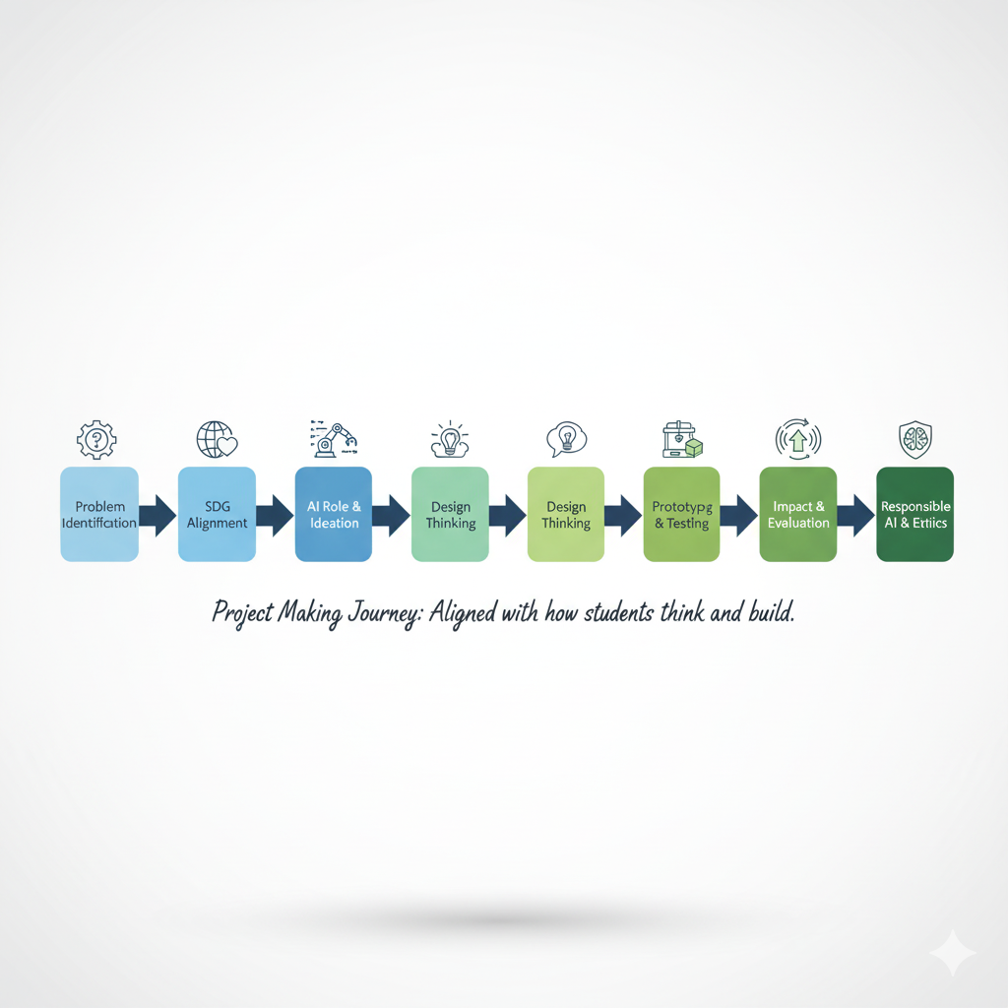
This project is your opportunity to demonstrate how AI can be a force for sustainability, inclusion, and positive change.

